 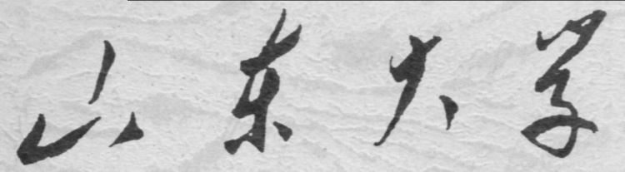

**崇新学堂**

**2022－2023学年第一学期**

实 验 报 告

课程名称： Experiments of Introduction to EECS

实验名称： Turning Heads

专 业 班 级 2021级崇新学堂

学 生 姓 名 葛明烨、余昊、崔宇鑫

实 验 时 间 2022年11月8日

**Step1**

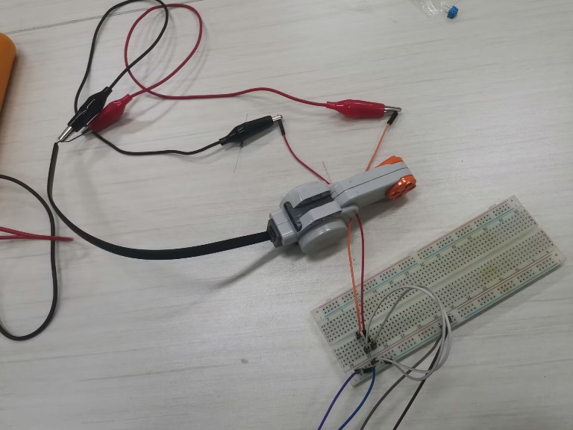

**In actual measurement, we found that Vmin is 0.2 higher than voltage dropped from high to low. We took a smaller value.**

**Step2**

**Step3**

***Check Yourself 1.***

**The motor is not running.** **,is short of the minimum voltage required to make the motor turn.**

**Step4**

**The unturned motor corresponds to the pure resistance in a circuit.**

**Because of the disparity between 10.2Ωand 1000Ω, almost all voltage was added into R1.**

***Check Yourself 2.***

**The theory matched the measurement in the previous part.No counter electromotive force is generated when the motor is not turned.**

**Step5**

**buffered divider circuit:**

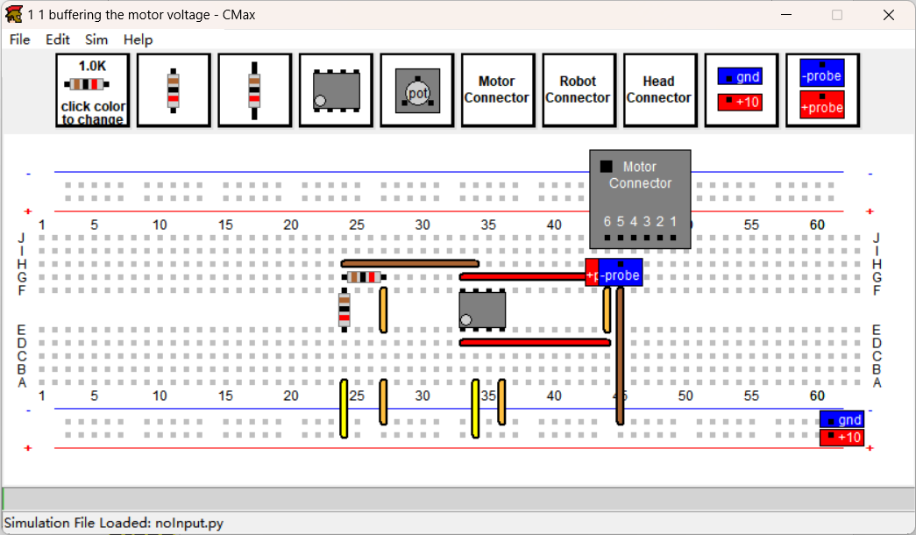

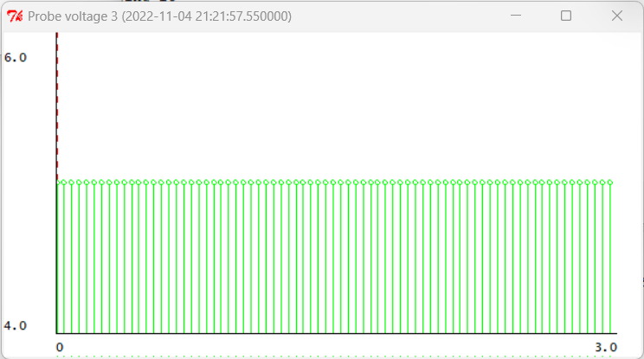

volltage of pin 5-6

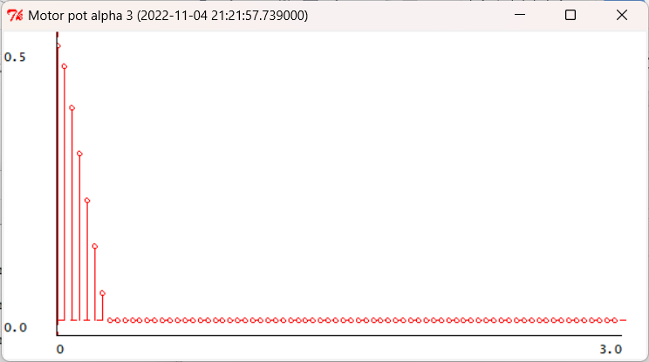

Motor pot alpha

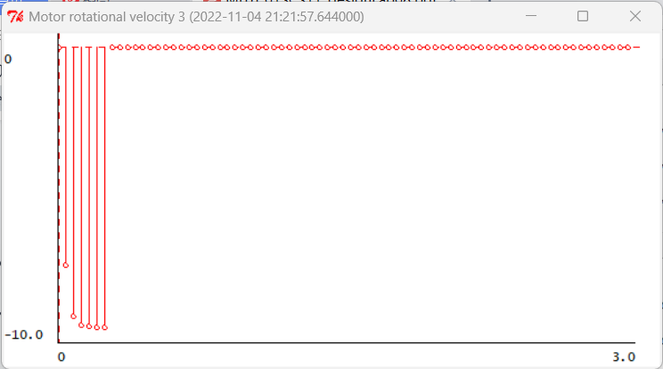

Moto rotational velocity

**Step6**

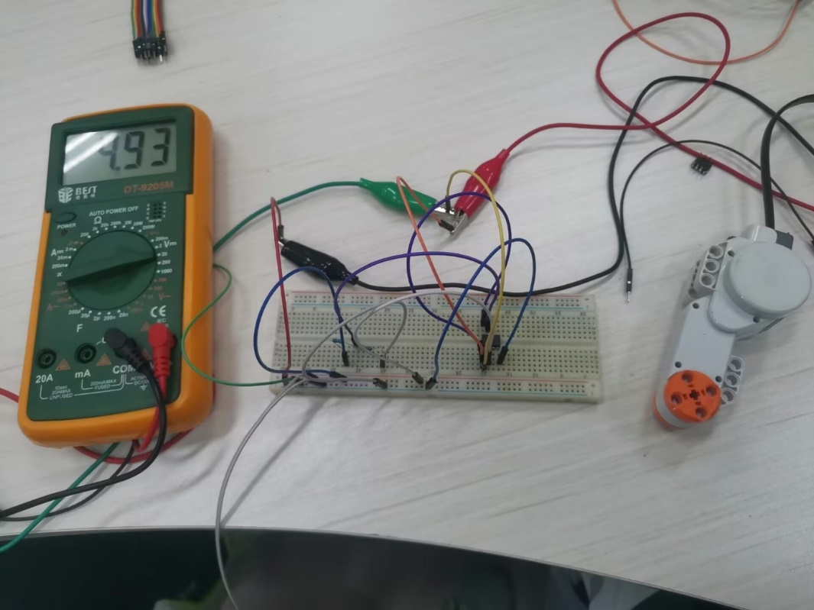

**Motor functions well**

***Check Yourself 3.***

**Buffered divider circuit created isolation between motor and basic circuit.It is a good way to get a special point volatge.** **Equivalent to output a new voltage source. 5V4.93V>0.53V Enough to drive the motor.**

**Step7**

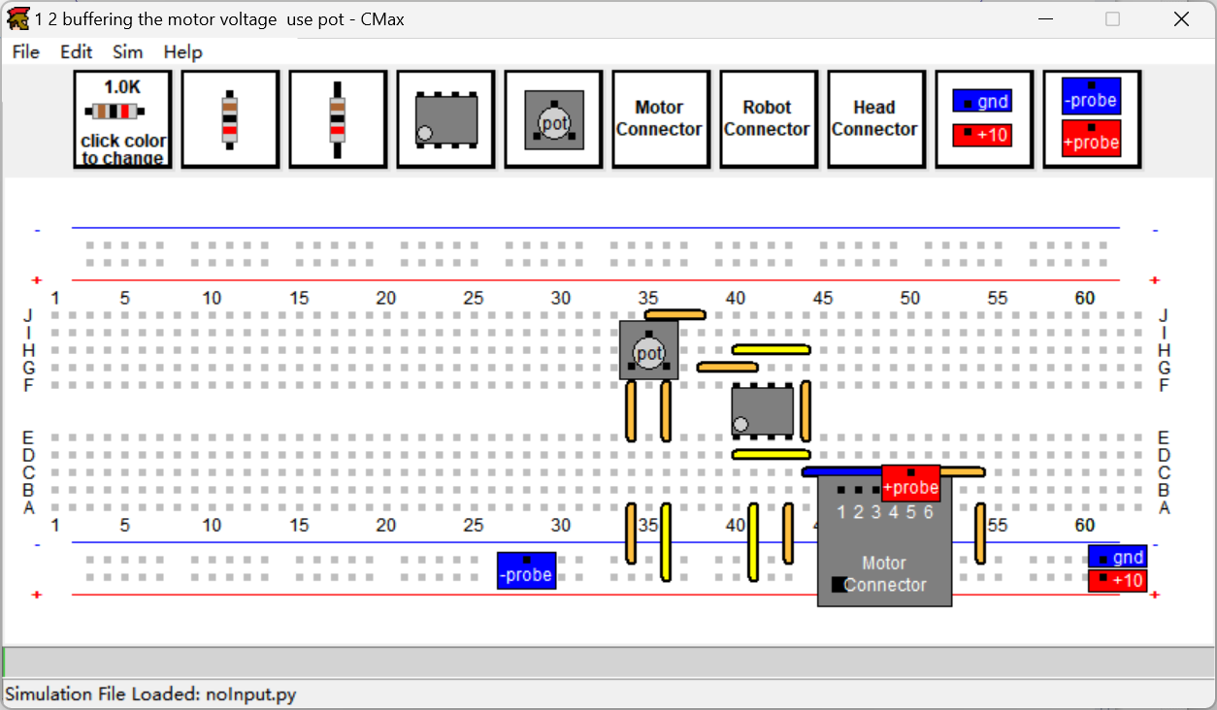

***Check Yourself 4.***

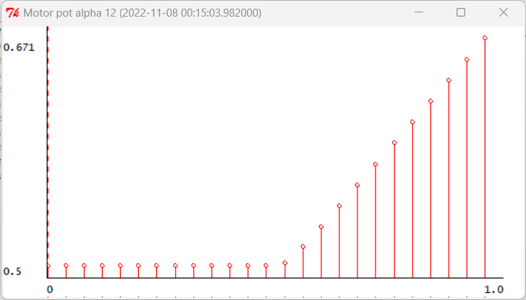

Motor pot alpha

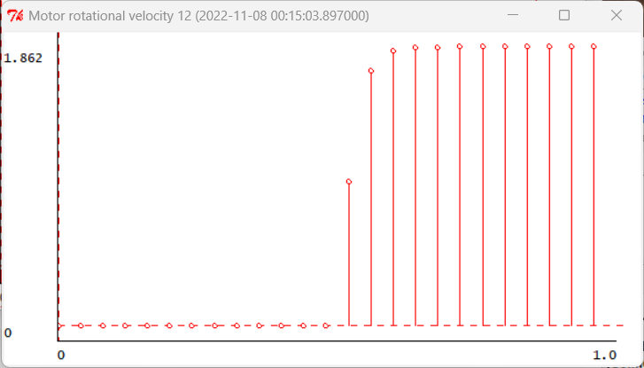

Motor rotational velocity

**In the first half of this graph,, the corresponding voltage is 0()**

**In the second half of this graph,gradually increase to a fixed value, the velocity of the motor is constant after buffering for a certain time()**

**Step8**

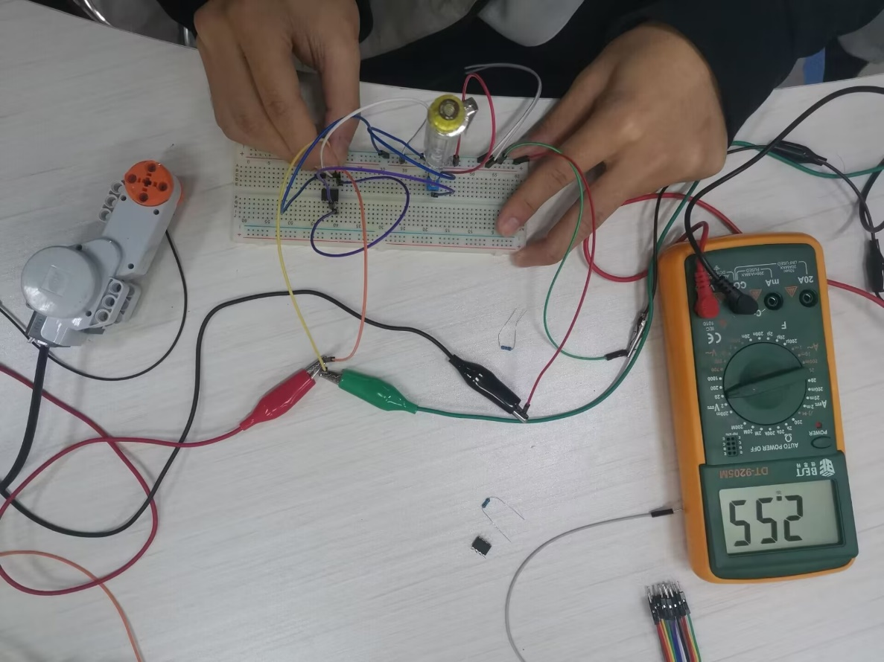

1/4 turn

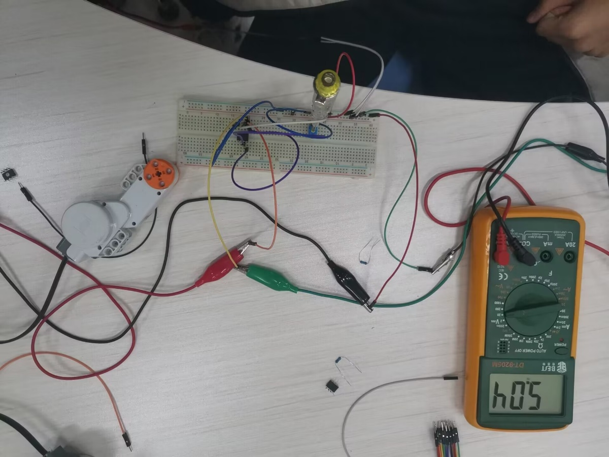

1/2 turn

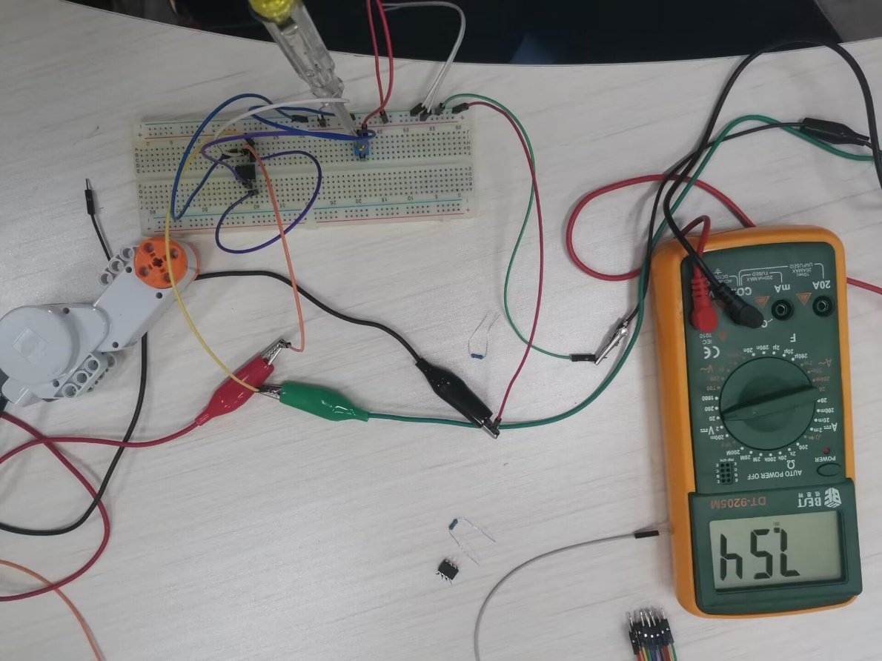

3/4 turn

**In actual measurement, motor rotational velocity quickly stabilized.** **The voltage value reflected the motor rotational velocity.**

**Step9**

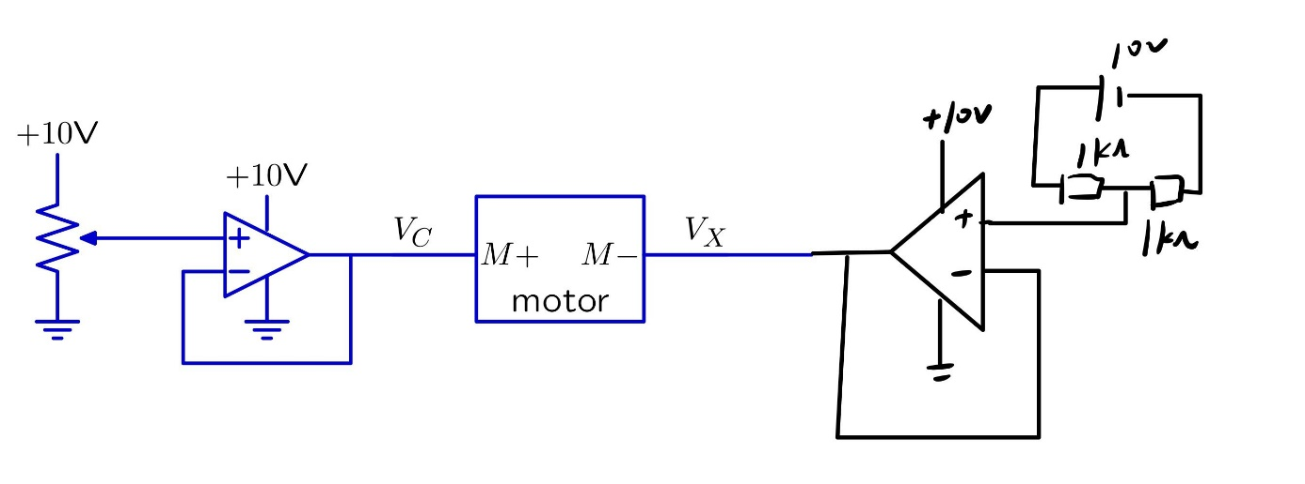

***Check Yourself 5.***

**We take a 5V node from a 10V node in a simple circuit.** **It is directly connected to the motor using the buffer.**

**Step10**

**Bidirectional Speed Controller circuit in CMax:**

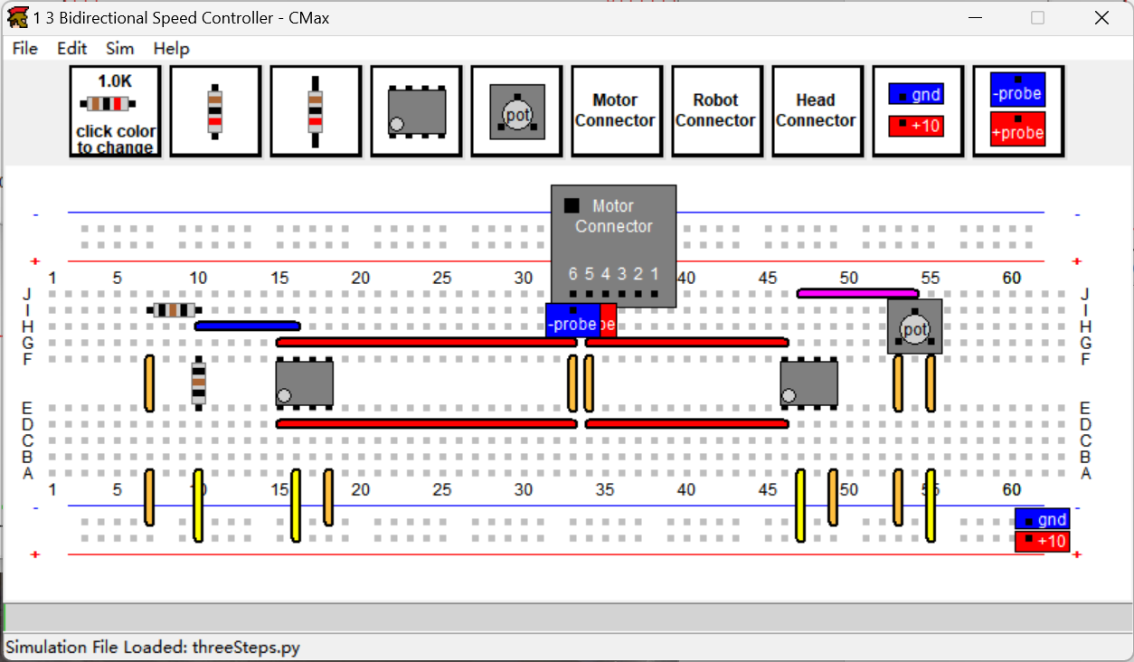

***Checkoff 2.***

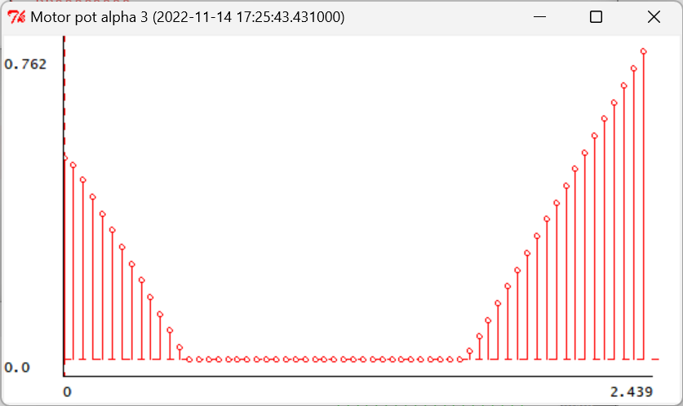

Motor pot alpha

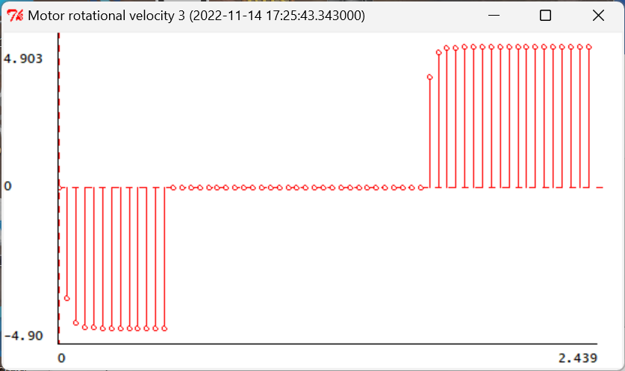

Motor rotational velocity

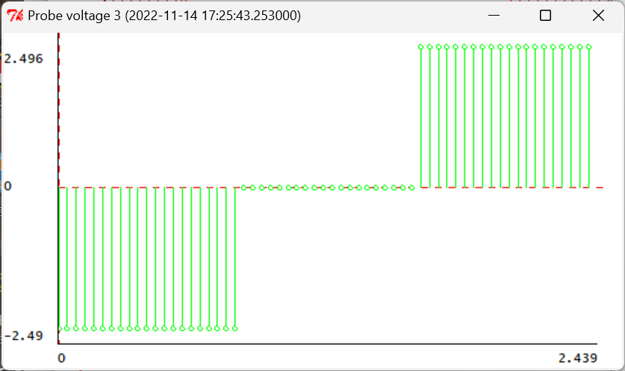

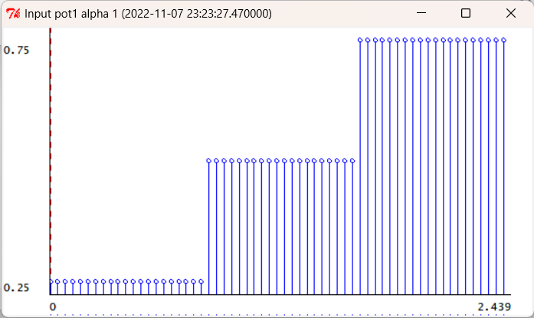

**Plus or minus of (V5-V6) is relative to motor rotational velocity.**

**When ,, *,*the motor rotates inversely.**

**When ,, *,* motor rotational velocity=0.**

**When ,, *,*the motor rotates normally.**

**We fixed Vm- to 5v, so that the whole circuit has an up-floating voltage in advance, so that when Vm+ changes from 0 to 10V, we can still obtain the corresponding negative voltage, to realize the motor reversal.**

**Summary**

1. **Buffering the voltage：To extract the voltage value at a point in the basic circuit without exposing it to the influence of other circuits。We can add an op amp to buffer the output of the resistor network.**
2. **Bidirectional controller：We can introduce a constant potential similar to ground as a comparison value at one end of the target position. When we cannot directly input negative voltage, we can consider comparing the voltage difference between the input end and the constant value to complete the target.**